Q1.

*Initial Accounts Table:*

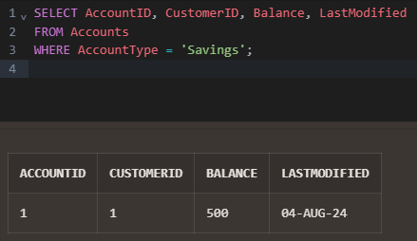

*PL/SQL Block:*

CREATE OR REPLACE PROCEDURE ProcessMonthlyInterest

IS

BEGIN

-- Update the balance for all savings accounts

UPDATE Accounts

SET Balance = Balance * 1.01,

LastModified = SYSDATE

WHERE AccountType = 'Savings';

-- Commit the transaction

COMMIT;

-- Output a message indicating the process is complete

DBMS_OUTPUT.PUT_LINE('Monthly interest applied to all savings accounts.');

END ProcessMonthlyInterest;

/

*Output:*

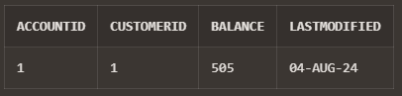

Q2.

*Initial Employees Table:*

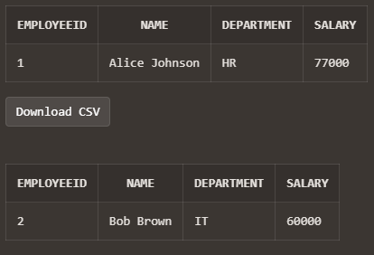

*PL/SQL Block:*

CREATE OR REPLACE PROCEDURE UpdateEmployeeBonus(

p_Department IN VARCHAR2,

p_BonusPercentage IN NUMBER

)

IS

BEGIN

-- Update the salary for all employees in the given department

UPDATE Employees

SET Salary = Salary * (1 + p_BonusPercentage / 100)

WHERE Department = p_Department;

-- Commit the transaction

COMMIT;

-- Output a message indicating the process is complete

DBMS_OUTPUT.PUT_LINE('Bonus applied to all employees in department ' || p_Department || '.');

END UpdateEmployeeBonus;

/

*Output:*



Q3.

*Initial Accounts Table:*

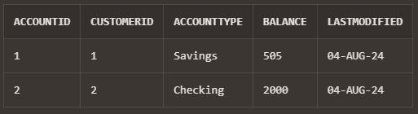

*PL/SQL Block:*

CREATE OR REPLACE PROCEDURE TransferFunds(

p_SourceAccountID IN NUMBER,

p_DestinationAccountID IN NUMBER,

p_Amount IN NUMBER

)

IS

v_SourceBalance NUMBER;

v_MaxTransactionID NUMBER;

BEGIN

-- Check if the source account has sufficient balance

SELECT Balance INTO v_SourceBalance

FROM Accounts

WHERE AccountID = p_SourceAccountID

FOR UPDATE;

IF v_SourceBalance < p_Amount THEN

RAISE_APPLICATION_ERROR(-20001, 'Insufficient balance in the source account.');

END IF;

-- Deduct the amount from the source account

UPDATE Accounts

SET Balance = Balance - p_Amount, LastModified = SYSDATE

WHERE AccountID = p_SourceAccountID;

-- Add the amount to the destination account

UPDATE Accounts

SET Balance = Balance + p_Amount, LastModified = SYSDATE

WHERE AccountID = p_DestinationAccountID;

-- Get the max TransactionID to generate new IDs

SELECT NVL(MAX(TransactionID), 0) INTO v_MaxTransactionID

FROM Transactions;

-- Record the transaction for the source account (Withdrawal)

INSERT INTO Transactions (TransactionID, AccountID, TransactionDate, Amount, TransactionType)

VALUES (v_MaxTransactionID + 1, p_SourceAccountID, SYSDATE, p_Amount, 'Withdrawal');

-- Record the transaction for the destination account (Deposit)

INSERT INTO Transactions (TransactionID, AccountID, TransactionDate, Amount, TransactionType)

VALUES (v_MaxTransactionID + 2, p_DestinationAccountID, SYSDATE, p_Amount, 'Deposit');

-- Commit the transaction

COMMIT;

EXCEPTION

WHEN OTHERS THEN

-- Rollback the transaction in case of error

ROLLBACK;

RAISE;

END TransferFunds;

/

*Output:*

